Report to Council

Author: Sarah Furniss, Clerk to the Council

Date 12 December 2018

Item 16Appendi7 | Grass Cutting Tender

- Introduction

The grounds maintenance contract expires on 31 March 2019. The purpose of this report is to agree matters in respect of the tender for the period 1 April 2019 to 31 March 2021).

- Proposed Timescales

Place Advert | 19 December 2018
Closing date for Expressions of Interest | 11 January 2019
Responding to Expressions of Interest | 14 January 2019
Deadline for Receipt of Tender | 4 February 2019
Review Tender | Between 6 and 8th February
Award of Contract | 15 February 2019
Contract Commences | 1 April 2019

Action Required: To agree the timescales which may be subject to amendment (see 3 Advertising).

- Advertising

Proposed wording for the advert and expressions of interest are below. Consideration needs to be given to where the advert will be displayed. This could include, Noticeboards, Website, Stratford Herald and direct mailing (to previous applicants). If it is agreed that the advert is placed in the Stratford Herald then the timescale above will need minor adjustment.

Grounds Maintenance Tender
Ettington Parish Council is undertaking a tendering exercise in respect of Grounds Maintenance for 1 April 2019 to 31 March 2021(with potential extension of contract for an additional year).
For more information the tender documents can be viewed at www.ettington.org.uk. Alternatively contact Sarah Furniss, Clerk to Ettington Parish Council, PO Box 6271, Stratford on Avon, CV37 1NX, 07786938072, epc.clerk@yahoo.com.

- The Tender
The Tender is based on that used in 2015 updated to reflect changes to the Playground Inspection. Once the timescales (Section 2 of this report) have been agreed the timescale table within the tender will be updated.

Action Required: To consider and agree wording of the contract.

Ettington Parish Council

Tender For Services Relating to Grounds Maintenance 1 April 2010 - 31 March 2021 (with potential one year extension)

Ettington Parish Council Grounds Maintenance
Section 1 - Introduction
1.1 The Parish of Ettington (including Fulready) is in South Warwickshire some 6 miles south-east of Stratford on Avon.

1.2 Ettington Parish Council is responsible for the provision of management of the playing fields.

1.3 The Council now wishes to tender for the following (full details included in The Grounds Maintenance Specification - Appendix 1).
- Grass cutting and strimming
- trimming and pruning hedges, verges, trees, shrubs
- providing and applying weedkillers
- maintenance of benches and other structures
- weekly and monthly inspection of play equipment
1.4 This tender will be a single stage process and is exempt, by reason of expected value, from the Official Journal of the European Community.

1.5 An Expression of Interest (Appendix 2) must be submitted according to the instructions therein by 5 October 2015. Failure to do so will exclude applicants from the tender process.

1.6 Any questions relating to this tender must be raised in writing no later than noon on 12 October 2015. Questions should be addressed to the Clerk: Ms S Furniss preferably by e-mail - epc.clerk@yahoo.com or by letter to Ettington Parish Council, PO Box 6271, Stratford on Avon, CV37 1NX. Any questions raised and the answers to those questions will be distributed to all companies or organisations that have submitted an Expression of Interest (Appendix 2) on 19 October 2015

1.7 All tender submissions must be received by the Clerk by noon on 2 November 2015 in a sealed envelope clearly marked "Confidential, Not to be opened until after 1.00 pm on 2 November 2015 in the presence of two councillors or one councillor and the Clerk to the Council".

1.8 Tenders received after the closing time and date will not be considered.

1.9 Tenderers should note that, as part of the evaluation process, they may be asked to attend a meeting at which they will be expected to give a presentation and answer questions on thier bid. Tenderers will be contacted if it is decided that a meeting needs to be arranged and such meetings will take place during week commencing 16 November 2015.

1.10 The Council is not bound to accept the lowest priced, or any, tender.

Section 2 - Instructions to Tenderers
2.1 It is the responsibility of the tenderer to obtain for themselves, at their own expense, any additional information necessary for the preparation of their tender.
2.2 All information supplied by Ettington Parish Council in connection with this tender shall be treated as confidential by tenderers, expect that such information may be disclosed for the purpose of obtaining sureties and quotations necessary for the preparation and submission of the tender.

2.3 All information submitted to the Council may need to be disclosed and/or published by the Parish Council. Without prejudice to the foregoing generality, the Council may disclose information in compliance with the Freedom of Information Act 2002.

2.4 Accordingly, if you consider that any of the information included in your tender response is commercially confidential please identify it and explain (in broad terms) what harm might result from disclosure/publication. It should be remembered though, that, even where you have indicated that information is commercially sensitive, the Council may disclose this information where they see fit. Receipt by the Council of any material marked "confidential" or equivalent should not be taken to mean the Council accept any duty of confidentiality by virtue of that marking.

2.5 Please note that the responses to any questions raised during the tendering period will be circulated to those who have submitted an Expression of Interest) in the form of a Circular Advice Note.

2.6 The evaluation will include emphasis on quality as well as price.

2.7 The contract period will be for two years, with an option to extend for a further year at the sole discretion of the Council.

2.8 The timescales relating to this tender are:

Action | Date
Place advertisement and circulate
Send out tender documentation
Last date for receipt of Expression of Interest
Closing date for questions relating to tender
Responses to questions relating to tender
Site Visits (if requested)
Closing date for return of tender
Delegated Councillors to meet and review received tenders
Interviews (if deemed necessary)
Selection Ratified at Council Meeting
Tender award date
Contract start date

Section 3 - General Information
3.1 Organisation Identity

3.1.1 Name of the Company in whose name business is to be transacted:
...................................................................................................................................
Contact person: .........................................................................................................
Registered Address: .................................................................................................
..................................................................................................................................
..................................................................................................................................
Tel no(s): ...................................................................................................................
e-mail ...................................................................................................................
3.1.2 Primary Address from which the services covered by the tender will be provided (if different from above).
Registered Address: .................................................................................................
..................................................................................................................................
..................................................................................................................................
Tel no(s): ...................................................................................................................
e-mail ...................................................................................................................

3.1.3 Please indicate below the principal types of business activity of your
company, and your main geographical area (if continuing on a separate sheet this should be headed "3.1.3").

3.2 Legal Information

3.2.1 What is the status of your organisation (eg, sole trader, limited liability partnership, public limited company, private limited company, charity etc).

3.2.2 Date of formation of organisation: .....................................................................

3.2.3 VAT Registration Number (indicate if not applicable)........................................

3.2.4 Are there any court actions and/or industrial tribunal hearings outstanding against your organisation? yes/no

If "yes" provide details on a separate sheet marked "Section 3.2.4"

3.2.5 Has your organisation been involved in any court actions and/or industrial tribunals over the last 3 years? yes/no

If "yes", provide details on a separate sheet marked "Section 3.2.5"

3.2.6 Please give the names and responsibilities of any Directors/Partners of your organisation (or indicate if not applicable):
Name | Title/Responsibility

Section 4 - Health and Safety
All contractors undertaking works under this tender must satisfy the Parish Council of their competency regarding Health and Safety.
4.1 Please enclose a copy of your organisation's Health and Safety Policy which should include details of how compliance is measured.

Section 5 - Human Resources
5.1 How many employees does your organisation employ?

5.2 Equal Opportunities Please note, if you are a One Person Business (ie no employees except the owner) then select OPB when give the option.

The Council has a duty to ensure Equality and this extends to its suppliers. Please, therefore, answer the following questions:

5.2.1 Is it your policy, as an employer, to comply with your statutory obligations under current UK Race Relations legislation? Yes/No/OPB

5.2.2 Is it your policy as an employer to comply with your legal obligations under the Equal Pay Act and also under relevant equality legislation not to discriminate on grounds of Disability , Sex, Sexual Orientation, Religion or Belief under relevant UK legislation? Yes/No/OPB

5.2.3 In the last three years, has any finding of unlawful discrimination in the employment field been made against your organisation by the Employment Tribunal, the Employment Appeal Tribunal or any court or commission in a formal investigation? Yes/No/OPB

5.2.4 In the last three years, has any finding of unlawful discrimination in ANY field been made against your organisation by the Employment Tribunal or any court or in comparable proceedings in any other jurisdictions on the grounds of alleged unlawful discrimination on the grounds of Disability , Sex, Sexual Orientation, Religion or Belief? Yes/No

5.2.5 In the last three years has any contract with your organisation been terminated on the grounds of failure to comply with either or both of:
a) Legislation prohibiting discrimination? Yes/No
or
b) Contract conditions relating to equal opportunities in the provision of goods, facilities or services? Yes/No

5.2.6 Has your business been convicted, in the last three years, of breaching any other areas of UK legislation? Yes/No
If you answer "yes" to any of the questions 7.2.1 - 7.2.5 please provide details, on a separate sheet, headed with the relevant question number, of date of each occasion, the finding and state what corrective organisational changes you have taken as a consequence.
5.2.7 Is your approach to equality set out in:
a) Instructions to those concerned with recruitment, selection, remuneration, training and promotion? Yes/No/OPB

b) Documents available to employees or their representatives?
Yes/NO/OPB
c) Recruitment advertisements or other literature?
Yes/NO/OPB

5.2.8 Are your staff with managerial responsibilities required to receive mandatory training on equal opportunities? Yes/NO/OPB

5.2.9 Is it your practice not to discriminate directly or indirectly on the grounds of Disability , Sex, Sexual Orientation, Religion or Belief in the provision of goods, facilities or services to the public? Yes/No

Section 6 - References
Please complete details below for at least 3 references for current or recent contracts/provision of services. The Parish Council may contact these referees as part of supplier evaluation immediately following receipt of tender and your permission to do so will be assumed.

Reference 1:
Contact Name ......................................................................................................
Phone No(s): .......................................................................................................
e-mail ...................................................................................................................
Address: ...............................................................................................................
................................................................................................................................
................................................................................................................................
Brief description of contract:
................................................................................................................................
................................................................................................................................

Reference 2:
Phone No(s): .......................................................................................................
e-mail ...................................................................................................................
Address: ...............................................................................................................
................................................................................................................................
................................................................................................................................
Brief description of contract:
................................................................................................................................
................................................................................................................................

Section 7 - Insurance
Please provide details of your organisation's insurance protection in relation to employer’s liability, public liability and professional indemnity.
Policy | Insurer | Value £
Employers Liability (please indicate if OPB)
Public Liability
Professional Liability

Please enclose a copy of the insurance certificates.

Section 8 - Environmental
8.1 Tenderers are required to remove from site(s) all waste materials incuding, but not restricted to - grass, wood and bark, paper, metals, plastics, glass.
Tenderers should indicate how they separate and dispose of the materials described in this clause, (if continuing on a separate sheet of paper use the heading "10.2") and indicate methods of storage of hazardous substance, eg fuel and weed control substances..
...................................................................................................................................
...................................................................................................................................
...................................................................................................................................

Section 9 - Additional Information
9.1 Please describe, on a separate sheet headed "11.1", your previous experience of providing services similar to those you wish to provide under this tender.

9.2 Indicate your maximum response times for non-routine works
Monday - Friday
08.00 - 18.00 ..............................................................................................
Saturdays
08.00 - 18.00 ..............................................................................................
Sundays/Bank Holidays
08.00 - 18.00 ..............................................................................................

9.3 Please provide any additional information you feel is relevant on a separate sheet headed "11.3". more space

Section 10 - Commercial Information
10.1 - Pricing Instructions:

10.1.1 A document indicating scope of work is attached (Appendix 1). You are required to review that document, and respond with appropriate costs on Appendix 3 - Pricing Schedule.

10.1.2 Prices indicated in Appendix 3 would apply for two years with the potential to extend for a further year subject to appropriate inflation uplift.

10.1.3 All work schedules are to be agreed with the council except for emergency action with a value of less than £250 as indicated in the specification (appendix 1)

10.2 Payment Terms

10.2.1 The Council will only make payment against itemised supplier invoices
10.2.2 Payment will be made by 12 equal monthly payments unless an alternative schedule is agreed;

10.2.2 Payments are currently made by cheque but may, in future, be paid by electronic means.

10.2.3 Cheques are issues after the Parish Council meeting that is held on the second Wednesday of the month. Invoices need to be received by the Clerk by the first Wednesday of the month to ensure payment. Invoices received after then will not be paid until the following month.

10.2.4 Invoices received for work that has not been authorised by the council (other than for emergency action) will be rejected.

10.2.5 If the supplier is declared bankrupt, is liquidated or placed into administration, the contract will immediately become nul and void.

10.2.6 If the supplier is found guilty of committing fraudulent acts (whether or not associated with this contract), the Council will have the right to terminate the contract without prior notice.

10.3 Site Visit
10.3.1 A site visit may be arranged prior to the tender closure date. If a formal site visit is not arranged, tenderers are expected to make their own visit to the Parish.

10.3.2 All tenderers are required to satisfy themselves that they are in possession of sufficient information to prepare a detailed, fixed price, offer. If any errors are made due to failure to obtain such information, the responsibility will lie with the tenderer.

Section 11 - Enclosure Check List
Please tick that you have enclosed the following details with your completed questionnaire, ensuring they are clearly cross referenced to the related section.
- Section 9 - Insurance
- Pricing Matrix
- List any additional separate sheets by their heading (eg 3.2.3).

Appendix 1
Ettington Parish Council
Grounds Maintenance Specification

1 General Grass Cutting - Community Centre (map a)
1.1 The Contractor is required to keep all grassed areas at 50mm or below at all times, and is required to carry out a minimum 30 cuts per annum within the boundaries marked in red (playing field) and brown (pitch area) on map (a).
1.2 Prior to cutting any area, the Contractor will remove all litter to ensure no injury to persons or damage results, and to avoid the shredding by machinery of any material. For the avoidance of doubt, litter is classed as stone, paper, tins, bottles, twigs and branches less than 25mm in diameter, and dog waste.
1.3 Mowing shall take place on the full area of grass up to the paving, walling and other boundaries including the base of all obstacles, trees etc. unless alternative arrangements have been agreed by the Council.
1.4 Where mowing equipment is not practical then the area should be strimmed;
1.5 The Contractor will clear all grass clippings arising from mowing operations from paved and tarmac areas, all footpaths, mowing margins, channels, memorials and plaques etc.
1.6 During very wet conditions, grass cutting shall cease if damage to the surface, levels and contours of the ground will occur. The Contractor is required to notify the Parish Clerk of the periods when cutting cannot be carried out.
1.7 The Contractor shall be required to re-cut any area that has not been maintained in accordance with this specification, at his own expense, raking off and clearing from the site any grass that has been cut when growth has reached a height above the upper parameter indicated.
1.8 The Contractor shall cut the verge on Rogers Lane in so far as the extent of the boundary of the Playing Field (as indicted in blue on map (a).
2 General Grass Cutting - Churchyard
2.1 The Contractor is required to keep all grassed areas at 50mm or below at all times, and is required to carry out a minimum 8 cuts per annum.
2.2 Prior to cutting any area, the Contractor will remove all litter to ensure no injury to persons or damage results, and to avoid the shredding by machinery of any material. For the avoidance of doubt, litter is classed as stone, paper, tins, bottles, twigs and branches less than 25mm in diameter and dog waste.
2.3 Mowing shall take place on the full area of grass up to the paving, walling and other boundaries including the base of all obstacles, trees etc. unless alternative arrangements have been agreed by the Council.
2.4 Where mowing equipment is not practical then the area should be strimmed;
2.5 The Contractor will clear all grass clippings arising from mowing operations from paved and tarmac areas, all footpaths, mowing margins, channels, memorials and plaques etc and the gate area.
2.6 During very wet conditions, grass cutting shall cease if damage to the surface, levels and contours of the ground will occur. The Contractor is required to notify the Parish Clerk of the periods when cutting cannot be carried out.
2.7 The Contractor shall be required to re-cut any area that has not been maintained in accordance with this specification, at his own expense, raking off and clearing from the site any grass that has been cut when growth has reached a height above the upper parameter indicated.
3 Hedge Cutting/Maintenance (edge of Playing Field)
3.1 The hedge to the boundary marked in green on map (a) to be trimmed (inner edge only) annually at a time deemed suitable by the Contractor;
3.2 The hedge to the boundary marked blue on map (a) to be trimmed twice a year (both sides and top);
3.2 Nuisance Branches: In cases where hedges have become overgrown such as to cause a nuisance or hazard the Contractor shall inform the clerk and an instruction issued to remove said branch(es) at the specified additional hourly rate;
3.3 All clippings, litter and other arisings shall be collected and removed at the end of each working day when the site will be left with a neat, tidy and safe appearance;
4 Fences
4.1 Fencing within the areas marked in red (playing field) and brown (pitch area) to be inspected in the spring and autumn of each year and any maintenance requirements notified to (overseeing Councillor/Clerk) and an instruction issued for required maintenance to be carried out at the specified hourly rate (if the total cost is likely to rise above £250 then this will be considered at a Council meeting).
5 Trees
5.1 The contractor will underake General Tree Maintenance of all trees within the areas marked in red (playing field) and brown (pitch area) on a three yearly cycle with one third of the trees to be pruned each of the three years. All pruning work to be undertaken between 1 December and 31 January.
5.2 All pruning will be appropriate to the size and type of tree and to include:
5.2a removal of sucker growth from the base of the tree;
5.2b removal of dead, diseased or crossing branches;
5.2c removal of low branches likely to cause an obstruction or interference to pedestrians or impede mowing operations;
5.2 All resulting prunings to be removed from the site at the end of the day such as to leave a neat, tidy and safe environment.
6 Weed Control
6.1 Weed control refers to the areas indicated in red (playing field), brown (pitches and blue (verge to Rogers Lane).
6.2Whenever possible weed control will be by physical means (ie strimming);
6.2 Chemical weed control should only be used in appropriate weather conditions and precautions using appropriate, eg COSHH, guidelines and should be taken to avoid damage by overspray to adjacent shrubs or plants
6.3 Chemical weed control will not be undertaken during school holiday or at weekends;
7 Tennis Court
7.1 Monitor the condition of the nets on a quarterly basis (by end of April, July, October and January) and report any maintenance requirements to (Clerk/Councillor);
7.2 To check and clear the surface of any windblown vegetation and litter as necessary;
7.3 To inform the clerk/councillor of any surface or fencing damage at the earliest opportunity but within 24 hours.
7.4 To undertake chemical weed control of the court edges 3 times per year.
8 Car Parking Area
8.1 In addition to requirements to clear debris in clauses 1, 2 and 3, twice a year the inner kerb edges of car parking will be cleared of accumulated debris.
9 Playground Equipment Inspection
9.1 A visual inspection of all play equipment within the grounds of the playing field will be undertaken weekly (approximately half an hour) and a physical inspection monthly (approximately one hour) excepting September when the annual safety inspection is undertaken by an approved organisation, (using the prescribed inspection report at Appendix a) and the report submitted to the Clerk to the Council.
9.1 If the Contractor can address the problem then he shall do so immediately; if not, he shall clearly identify the seat with hazard tape and/or notices to state it cannot be used and notify the Clerk who will agree what action to be undertaken. If the work to be undertaken is likely to be in excess of £250 then will include on Agenda for next available meeting;
10 Benches/Seating Inspection and Maintenance (as detailed at map (a), (b) and (c)
10.1 At each site visit the Contractor shall visually check the benches/seating and their bases for the following:
10.1a Damage or breakage;
10.1b Hazards including, but not exclusively, glass, nails, etc;
10.1c Graffiti
10.2 If the Contractor can address the problem then he shall do so immediately; if not, he shall clearly identify the seat with hazard tape and/or notices to state it cannot be used and notify the Clerk who will agree what action to be undertaken. If the work to be undertaken is likely to be in excess of £250 then will include on Agenda for next available meeting;
11 Replenishment of Dog Waste Bags
11.1 To check supply and replace as necessary;
11.2 To notify the Clerk when further supplies of bags are required;
12 Mowing Equipment and Machinery
Note to tenderers - indicate in your pricing document whether you will opt for 12.1(a) or 12.1 (b); if either option would be acceptable then clearly indicate this and provide two contract prices.
Contractor Provided Equipment
12.1(a) The Contractor shall provide all plant and equipment necessary for the contract. All mowing machines shall be well maintained, cutters to all mowers shall be sharp and properly set up so as to cut the grass cleanly and evenly at all time
or
Using Ettington Parish Council Mower
12.1(b) i. The Contractor shall provide all plant and equipment necessary for the contract with the exception of the mower which will be provided by Ettington Parish Council for the exclusive use of the Contractor but which the Contractor will be responsible for fueling.
12.1(b). ii Ettington Parish Council will arrange for the mower to be serviced annually;
12.1(b) iii The Contractor to have a set of keys to the mower shed and to ensure it is secured at all times when the contractor is not at the mower shed.
12.1 (b) iv The Contractor to inform the Clerk immediately if the mower requires any maintenance.
12.2 All machinery shall for the duration of each and every use, be fitted with adequate safety guards, and machinery and plant shall be properly silenced and maintained in accordance with the manufacturer’s instructions.
12.3 All wheeled grass cutting machinery must be fitted with tyres specifically designed for use on turf.
12.4 No machinery shall be refuelled or lubricated on the grass areas.
12.5 In the event of any operation or activity carried out by the Contractor being of detriment to the structure of the facility or area, the Contractor will be responsible for the cost of all remedial works which would be required.
13 Health and Safety
13.1 The Contractor will comply with the Health and Safety/Risk Assessment best practice.
13.2 All persons operating machinery and equipment must be appropriately trained. The Contractor shall provide, if asked, adequate proof that all operatives are well trained and conversant with Health & Safety legislation, are competent in their operating methods;
13.3 The Contractor is required to notify the Parish Clerk immediately of any accidents, near misses or environmental incidents such as oil or diesel spillages. The Contractor is expected to carry spillage kits.
14 Insurance
14.1 The Contractor will maintain Public, Profession and Employer (if appropriate) Liability Insurance throughout the term of the Contract.
15 Other
15.1 To undertake other grounds maintenance work, eg provision and installation of new fencing, mowing of other grass areas, foundation work for new benches, as requested by the Parish Council at hourly rate as specified in the tender submission.

Appendix A
Playground Equipment Safety

In order to ensure the safety of users and to comply with insurance requirements regular inspections of playground equipment are necessary and, if damage is found, the equipment should be "off limits" until remedial work ensures safety.

A record of inspections must be maintained and the Clerk notified of any problems requiring attention.

Annual Inspection: An annual inspection will be undertaken by a professional organisation.

Ettington Children’s Play Area – Weekly Visual Inspection Checklist
Site - General Items to inspect
Ref. | Description | Ref. | Description
G1 | Is perimeter fencing undamaged and not a hazard? | G5 | Are seats, benches, tables undamaged and in good order?
G2 | Are trees in and around the area safe and in good condition? | G6 | Is the general grassed surface area free from trip hazards?
G3 | Is the site free from litter, debris, glass, sharps and animal fouling? | G7 | Is the area well drained and puddle free?
G4 | Is the gate and closure mechanism in good working order (min 5secs. closing;min 12mm gap either side)? | G8 | Is the area free from any unauthorised items?
G9 | Are the Benches in good and safe condition | G10 | Are the surfaces under benches undamaged

Swings – Items to inspect
S1 | Are supports secure and free from decay at ground level? | S6 | Are the seats securely fixed with secure centre bars on cradles?
S2 | Is all metal work undamaged and free from corrosion? | S7 | Are wet pour safety surfaces undamaged and hole free?
S3 | Are all fixings secure? | S8 | Are the surfaces weed free?
S4 | Are all chains intact and in good condition with less than 40% wear? | S9 | Are the surfaces level with surrounding ground and free from trip hazards?
S5 | Are the swing seats unbroken with no exposed metal?

Slides – Items to inspect
SL1 | Are supports secure and free from decay at ground level? | SL5 | Is the chute securely fixed and clear of foreign objects or protrusions?
SL2 | Is all metalwork undamaged and free from corrosion? | SL6 | Are wet pour safety surfaces undamaged and hole free?
SL3 | Are steps in good condition and not slippery? | SL7 | Are the surfaces level with surrounding ground and free from trip hazards?
SL4 | Are hand rails secure and in good condition? | SL8 | Are the surfaces weed free?
ANY OF THE ABOVE ITEMS AND THOSE OVERLEAF WHICH REQUIRE ATTENTION MUST BE IDENTIFIED ON THE WEEKLY EXCEPTION REPORT WITH RELEVANT DETAILS, REMEDIAL ACTION REQUIRED, AND LEVEL OF URGENCY.

Roundabout-items to inspect
Ref. | Description | Ref. | Description
R1 | Is it undamaged, free of corrosion, and is the platform level? | R5 | Is it clear of rubbish underneath?
R2 | Does it revolve smoothly and without noise? | R6 | Is the wet pour surface undamaged and hole free?
R3 | Are there no protruding bolts etc. under the platform? | R7 | Is the surface level with surrounding ground and free of trip hazards?
R4 | Are seats/handrails securely fixed and in good condition? | R8 | Is the surface weed free?

Rocking Equipment – items to inspect
RE1 | Are all supports and springs present, secure and free from decay at ground level? | RE5 | Are wet pour surfaces undamaged, hole free, and clear of weeds?
RE2 | Does the item move smoothly and noiselessly? | RE6 | Are grass surfaces in good condition without undue wear?
RE3 | Are all handgrips and footrests present and securely fixed? | RE7 | Are surfaces level with surrounding ground and free of trip hazards?
RE4 | Is all material in the constructions in good condition?

Climbing and Agility/Miscellaneous Equipment – Items to inspect
M1 | Are all supports secure and free from decay at ground level? | M6 | Are all balance posts etc. secure, in good condition and with non-slip tops?
M2 | Is all timber and metal work undamaged and free from corrosion? | M7 | Are any wet pour surfaces undamaged, hole and weed free?
M3 | Are all bars in place, securely fixed and tube ends plugged? | M8 | Are grass surfaces in good condition without undue wear?
M4 | Are all ropes/chains in good condition and firmly fixed? | M9 | Are surfaces level to surrounding ground and trip hazard free?
M5 | Are all nuts and bolts secure without any projecting thread?

Ettington Play Area Safety Inspection
Record of Inspections (to be undertaken weekly)

Date | Satisfactory  (Yes/No) | Report Submitted to Clerk (yes/no) | Signed

Appendix 2
Ettington Parish Council

Expression of Interest Form
To: Ettington Parish Council
PO BOX 6271, Stratford on Avon, CV37 1NX
e-mail epc.clerk@yahoo.com
THIS FORM MUST BE RECEIVED BY NOON on 5 OCTOBER 2015- FAILURE WILL RESULT IN EXCLUSION FROM THE TENDERING PROCESS

Date: ............................................................................
Company Name: ..........................................................
Contact Name: .............................................................
We confirm our interest in tendering for the grounds maintenance contract
Any further information in respect of this tender, including answers to questions raised by any tendering organisations should be addressed to the following:

Name: ................................................................................................................................

Address: ............................................................................................................................

...........................................................................................................................................

...........................................................................................................................................

Tel No(s): ...........................................................................................................................

e-mail: ...............................................................................................................................

Signed: ...............................................................................................................................

Appendix 3

Ettington Parish Council
Grounds Maintenance Pricing Schedule

Work required in Specification to be carried out during normal working hours (07.00 - 18.00 Monday to Friday). Price should indicate a single price per annum.
a) Using own equipment

£

b) Using Parish Council Equipment (mower only which will be serviced annually but which the tenderer will be responsible for fuelling).
£

nb: tenderers can complete one or both of the above boxes for the Council's consideration.
Price per hour for additional general services
£

Appendix 4 Maps
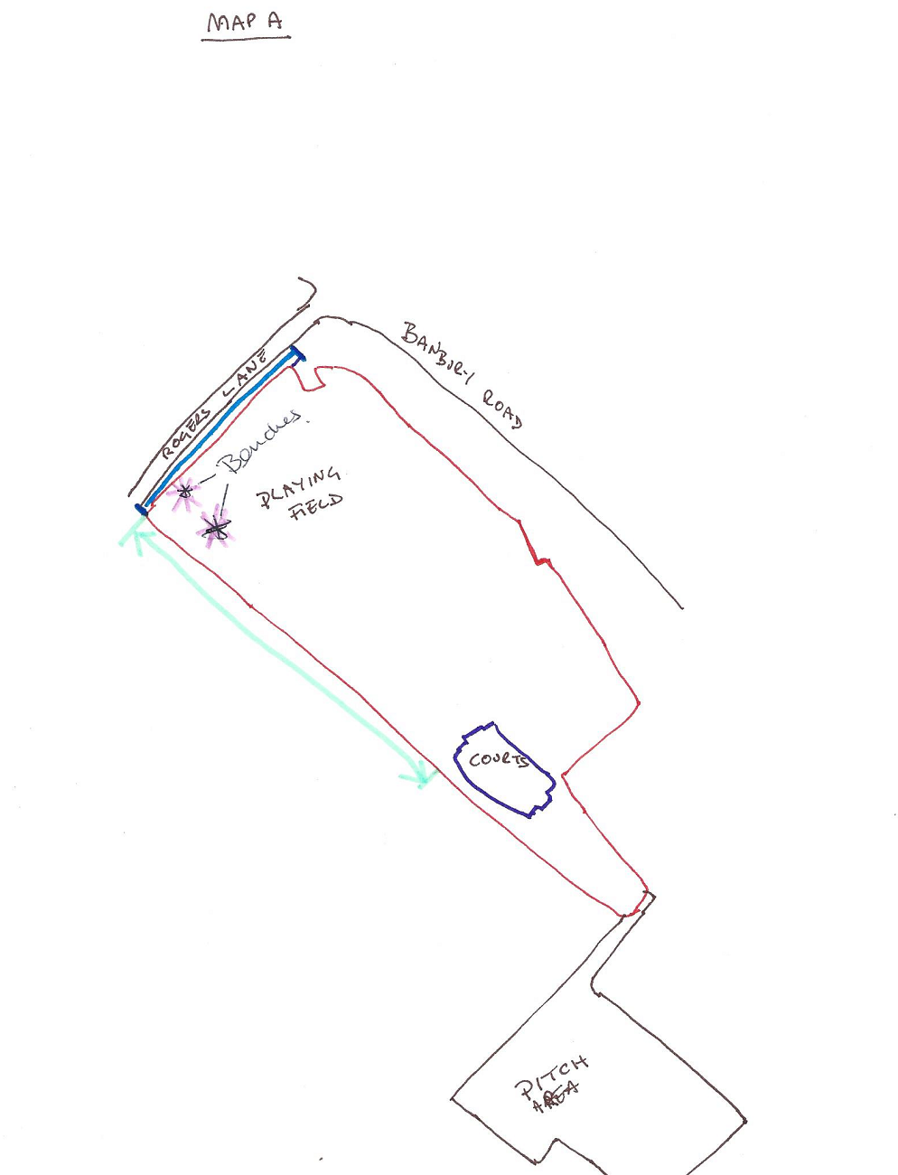

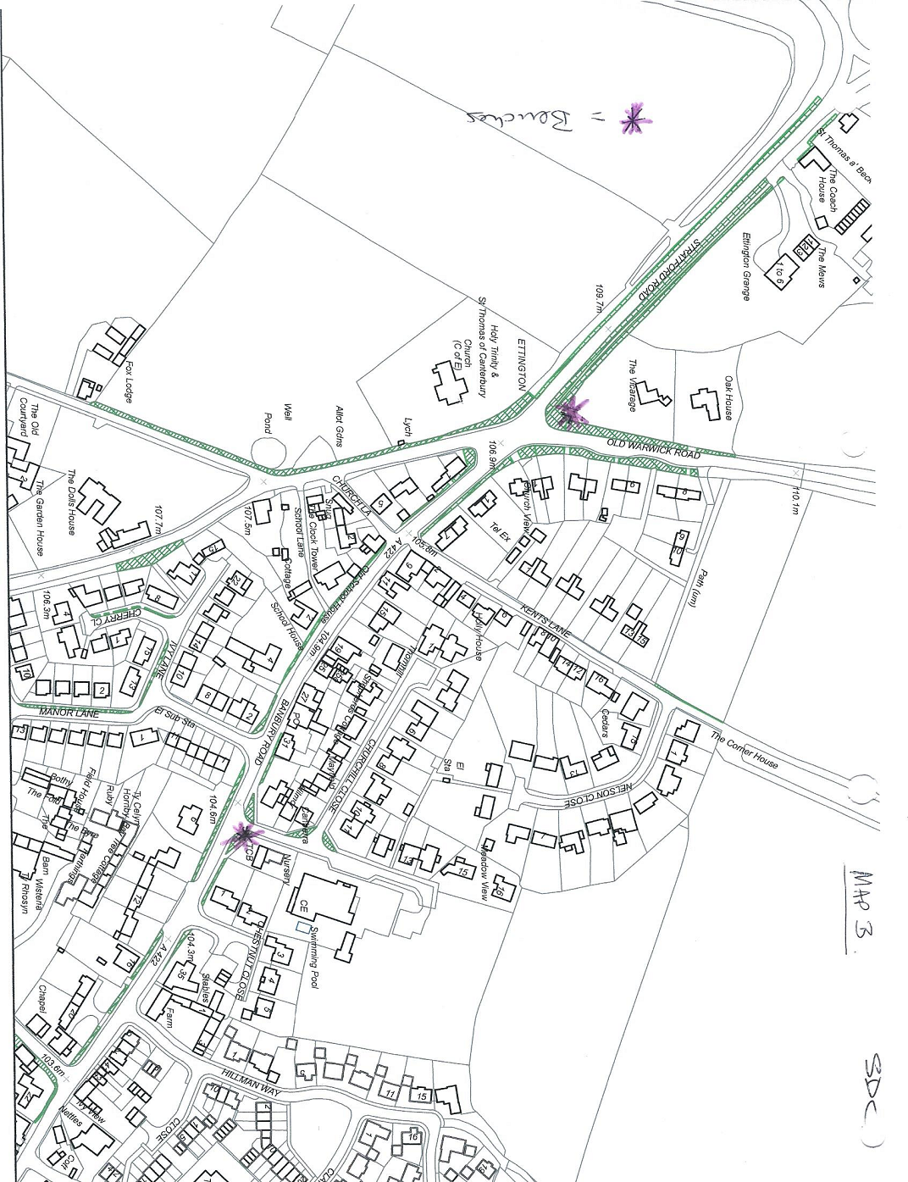

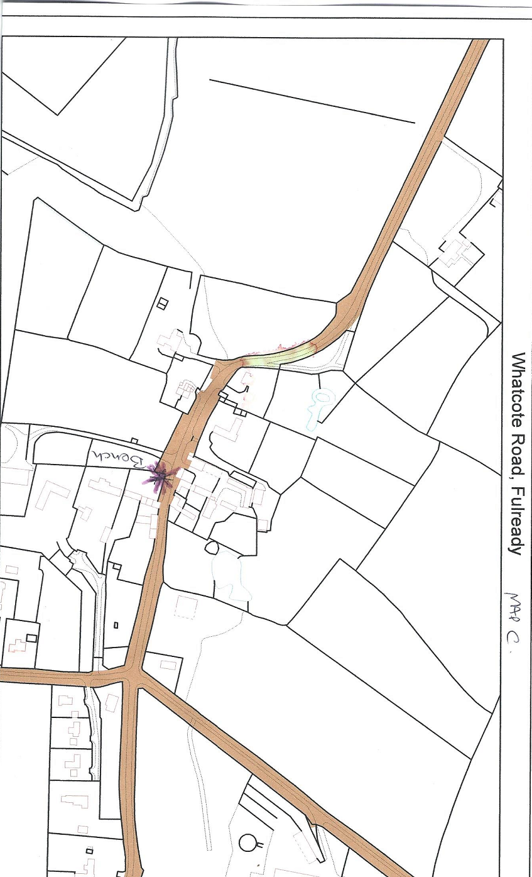
The plan below shows the location of a skatepark which is to be built (start date to be notified to successful contractor).
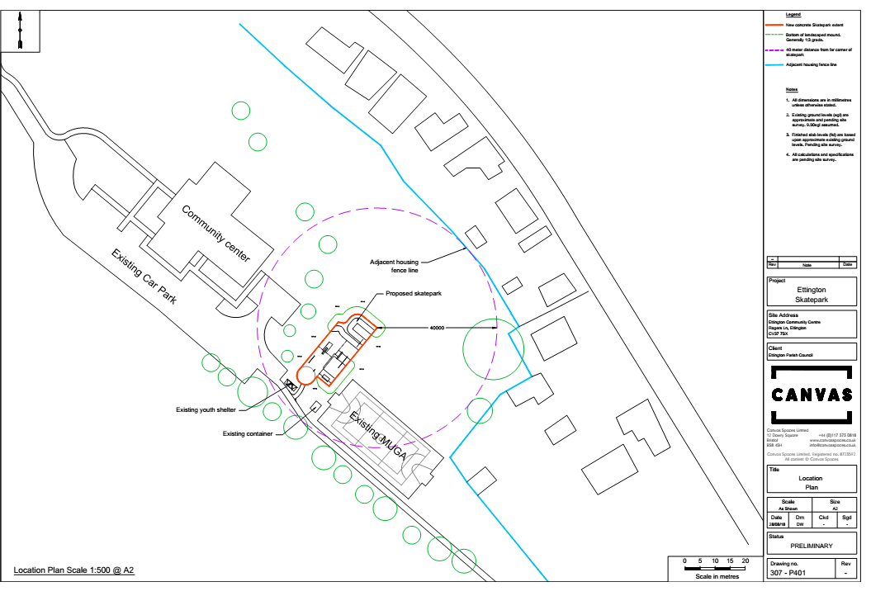

- Decision Matrix

Ettington Parish Council - Grounds Maintenance Tender Scoring Sheet

Tender applicant……………………………………………………………………………

Expression of Interest Received by xx Yes/No
Tender Received by xxx Yes/No
Any Court Actions Pending/in last 3 years Yes/No
Criteria | Evidence | Degree of Achievement (1, 2 or 3) | Weight (importance 1, 2 or 3) |  | Total DoA x W =
Promoting Local Enterprise/Business | Eg, Strong association with Parish |  | 3
Proximity of Contractor’s Base (in case of emergency call out) | Address |  | 3
Flexibility of approach |  |  | 3
Consistency of provider | Eg, sole trader (3)/small company(2) /large company( 1) and Q5.1 |  | 3
Health and Safety | Content of H&S policy |  | 3
Employment Track Record | Q 5.2.3, 5.2.4, 5.2.5, 5.2.6 | Achievement = 1  Non achievement = 0 | 2
Environment | Section 8 |  | 2
Response times | Section 9 |  | 1
Price | Using Own Mower |  | Using PC Mower *

Section 7 – No tender will be awarded without satisfactory insurance and this will be a stipulation of the contract but not having insurance will not preclude offering of the contract but will be made subject to achievement.

Section 6 - Any decision will be subject to satisfactory references or previous service delivery to EPC.

Action Required: To consider and agree wording of Decision Matrix

6 Other Matters for Consideration

- To discuss and agree who will undertake evaluation of tenders and whether authority can be delegated to them to make a final decision or whether their recommendation should be approved by the full Council.

